Enter (Type) Hands into aaBridge

Compiled by Roger Pfister http://RogerPf.com/aaBridge

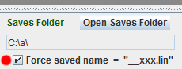
Set up
Lift the bottom slider and check the Force saved name = __xxx.lin check box. (red dot)
Here the saves folder is set to C:\a\ but the normal default will work fine. (You must restart aaBridge if you do change it)
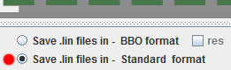
Select Save .lin files in - Standard Format (red dot).
- You have bridge hands on paper or in some format that might as well be paper (like in a .pdf file) and you want to get those hands into aaBridge. (Perhaps later get them up to BBO).

- With your Simple Editor (Notepad++ Windows or BBEdit Mac) see links on the final page create a file e.g. myDeals.lin the file needs to end with the '.lin' extension.
HINT To show file name extensions (.lin) on your computer see the links section at the end.
- In add (type-in) just the 4 characters md||
those two vertical lines are the 'bar' character.

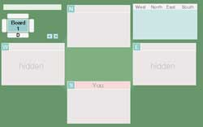
- Drag & Drop myDeals.lin on to an open aaBridge window.
The empty deal will now show, see image.

<continued on next page>

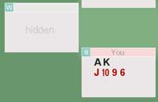
- Start to add in the cards.
First the South, then West then North
The hands are separated by commas ',' and the suits by spaces
and are put in SHDC order.
At this stage do NOT add any suit characters (SHDC).
Add in '10' as 't', void as '-'.
For example, type so that the line now reads md|4ak jt96|
and do a
File Save (Ctrl S is the Notepad++ shortcut).
The aaBridge window will change and show as (see image).
- DEALER The 4 in front of the ak is optional and sets the dealer to be East. See later.
If omitted it will default to 1 (South).
If South's spades are ALL 4 or less you DO need to add the 'dealer identifier', otherwise the first card you list will be swallowed and treated as defining the dealer.

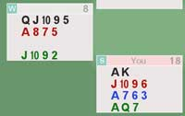
- Keep adding cards and saving
when you have all 13 cards that hand's Point Count will show. So
md|4ak jt96 a763 aq7, qjt95 a875 - jt92|
and a File Save will show as (see image).

- When you have completed 3 full hands, aaBridge will fill in the 4th hand for you (not shown).

- Check that all four hands show a Point Count. If a hand does not it means that, the hand is missing a card.
By eye compare your hands with the ones shown in your printed illustration. Don't assume you are at fault (but you maybe). Old books can have misprints too. Duplicated cards can cause some head scratching.
HINT – it is much easier to get the cards right now. Doing it later is a lot more work.
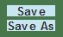
- When you have all four hands looking correct you can save using the save button, (because of the earlier setting) it will save to __xxx.lin.

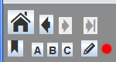
- Open the new __xxx.lin file in your simple text editor. If you are on Windows and you have Notepad++ installed corrected OR are on a Mac you can use the pencil icon. (red dot)
The file should look something like this.
qx|1|
rh||ah|Board 1|
md|4sAKhJT96dA763cAQ7, sQJT95hA875cJT92, s432hKQ43dKQ84c53, s876h2dJT952cK864|
sv||sk||pg||
- Copy ALL the contents from the file __xxx.lin and add it to your myDeals.lin
when doing so REPLACE ALL of the line you have just typed in.
This also ensures that your deal e.g. md|4sAK...| always ends in a pg|| IMPORTANT
- To change the Board number change BOTH green '1's to the same number.
- To change the Dealer change the red '4' to be 1=South 2=West 3=North 4=East
- To change the Vulnerability change empty sv|| to have some text
<empty> = none n = NS e = EW b = Both
(In other lin files you may see "O" for none).
- You can build up multiple deals in your myDeals.lin file.
For clarity, put a blank line between each of them.

- As you add each deal you will see that Deal's 'bobble' appear on the Navbar
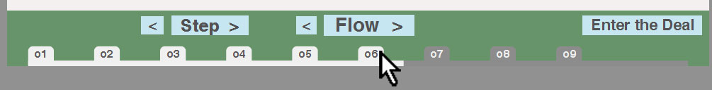

- You can add in the bidding by typing the bids in to the myDeals.lin file at the end of the hand
mb|p|mb|1c|... you must end with pg||
this is not recommended. Instead use the method that follows.

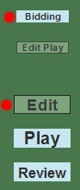
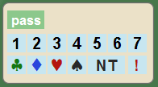
- To enter any Bidding
Select that deal on the Navbar,
click 'Enter the Deal'
click Edit (the buttons are on the right) and then
click Bidding and
use the bidding buttons that will appear.
- Click the Save button and in your editor, copy the line of bidding that will now be in the __xxx.lin into the myDeals.lin file. The line will already end with a pg||
- Alerts are added by hand adding the an|...| 'annotate' command immediately after the bid.
eg: mb|2c|an|Stayman| an|| will show as a 'no text' alert.
mb|2c!| will also show as a, 'no text' alert.

- Opening Lead and Play as with bidding you can enter the lead with pc|| play card.
eg: pc|sK| you must end with a pg|| and again this is NOT recommended
Preferred is click the Edit Play button (see the tall green image above) and Enter the play by clicking on each card in turn from each hand in turn.
- Click the Save button and in your editor, copy all the play (there could, of course, be all 13 tricks in the __xxx.lin file) into the myDeals.lin file.
The lead and the end of each trick will already end with a pg||
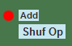
- eb|___y| and Early Play What is all this ? Sometime you can be entering a problem deal with play and you want to force the defenders (normally E-W) to play is a set way for a trick or two. For example you want to start with West cashing their AK of hearts and switching to the 4 of clubs.
The solution is to enter the play up to and including the 4 of clubs (and NO further) and then to click the Add button just above Shuf Op (red button). When save this will show as
pc|c4|eb|___y|pg|| This will preserve any play up to and including the 4 of clubs.
Read the doc collection doc Easy_Lin_a_How_to.doc and look out for Early Play.
There is now a MORE ADVANCED feature that will solve this problem and do even more.
Read the doc collection doc Hints for Bots - a How to.doc

- Safety There are lot of "save the __xxx.lin file" steps in the above description. These are for safety. If you are skilled enough you can enter the cards, the bidding and lead and at the end only do one save to the __xxx.lin file. But a single mis-click and your work of, for example, entering the bidding and play, will vanish.

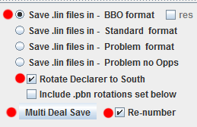
- Converting to BBO Upload Format at this point you have a myDeals.lin file full of all your deal but they are all in Standard Format. If you aim is to produce a set of hands that you can upload to BBO.
Select the Save lin files in – BBO format radio button.
optionally
check Rotate Declarer to South
check Re-number
Click Multi Deal Save
a file called myDeals__BBO.lin will now be created next to your myDeals.lin file.
To actually copy lin files into BBO is not part of aaBridge but see the links on the final page.

Thank you for reading

<continued on next page>
Appendix

How to get - aaBridge Hands up to BBO

See the doc collection document
Get aaBridge hands up to BBO - a How to.doc

See aaBridge on YouTube You want the final 30 seconds of video
006 Typing deals into aaBridge and so to BBO

Editors and Other Hints

A good FREE simple editor for Windows is
notepad++ from https://notepad-plus-plus.org/

also see the aaBridge doc collection for - Notepad++ How to setup for Windows.

A good FREE simple editor for MAC is

BBEdit from http://www.barebones.com/products/bbedit/download.html

(or look in the MAC Store for BBEdit)

How to show file extensions e.g. .lin on your computer
for Windows see

https://www.howtogeek.com/205086/beginner-how-to-make-windows-show-file-extensions/

for MAC see

https://support.apple.com/kb/PH19072?locale=en_US

<end of document>

